# Anazah Essora – Premium Whole Spices Catalog

## Black Pepper (Whole)

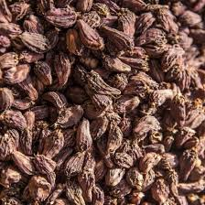

Sourced from premium pepper-growing regions of India, Whole Black Pepper is valued for its bold aroma, sharp heat, and high essential oil content. The peppercorns are carefully selected and cleaned to preserve freshness and natural pungency.  
  
Widely used across Indian, continental, and Asian cuisines, whole black pepper enhances curries, soups, marinades, salads, spice blends, and seasoning mixes. Freshly crushed pepper releases maximum flavour, making it ideal for both everyday cooking and gourmet preparations.

## Green Cardamom – Small

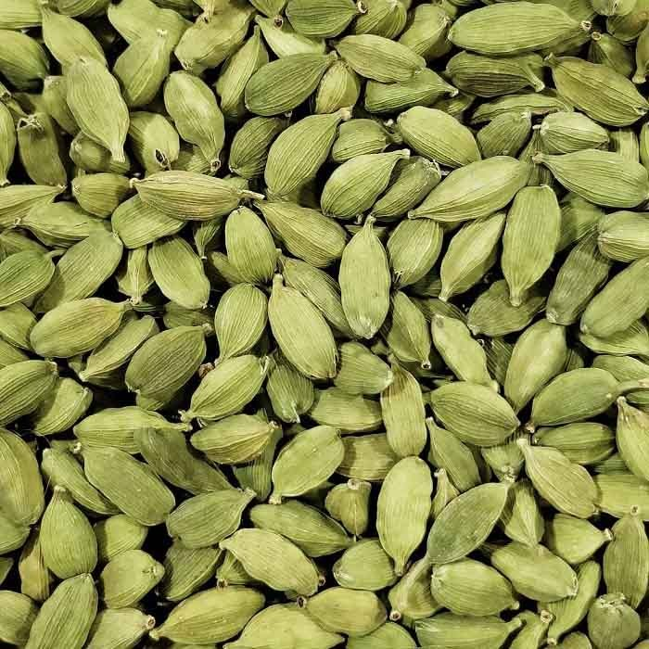

Small green cardamom pods are sourced from traditional high-altitude growing regions known for balanced aroma and sweetness. These pods offer a refreshing fragrance with mild warmth.  
  
Ideal for desserts, tea, sweets, kheer, pulao, and festive dishes. Lightly crushed pods release aroma that elevates both sweet and savoury recipes.

## Green Cardamom – Large (7.5 mm & above)

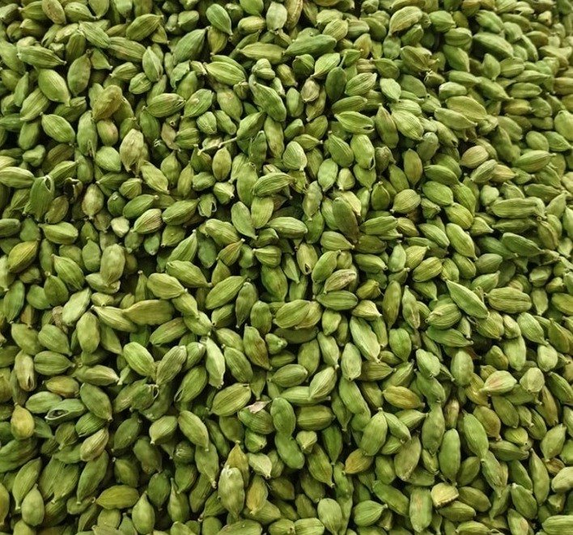

Premium large green cardamom pods are hand-graded for size, colour, and oil content. These pods deliver intense aroma and deeper flavour compared to smaller grades.  
  
Best suited for biryanis, premium desserts, specialty teas, and culinary applications where aroma and visual appeal matter.

## Black Cardamom



Black cardamom is sourced from Himalayan regions and is known for its bold, smoky aroma. The large pods impart deep, earthy flavour to slow-cooked dishes.  
  
Widely used in biryanis, meat curries, and gravies, black cardamom adds complexity and warmth when used whole during cooking.

## Cumin Seeds (Jeera)

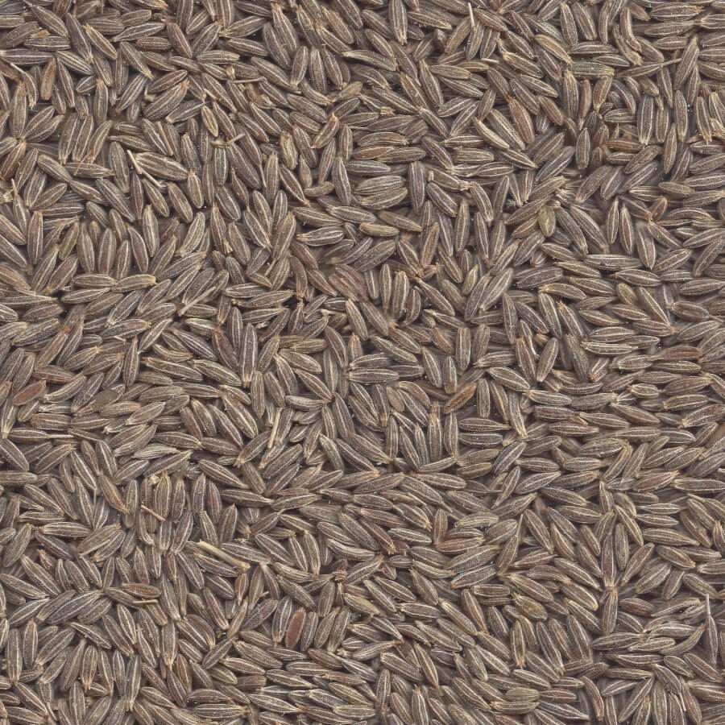

Cumin seeds are carefully sourced for strong aroma and uniform size. They carry warm, earthy notes essential to Indian and global cuisines.  
  
Used extensively in tempering, rice dishes, curries, spice blends, and roasted snacks. Light roasting enhances flavour release.

## Coriander Seeds

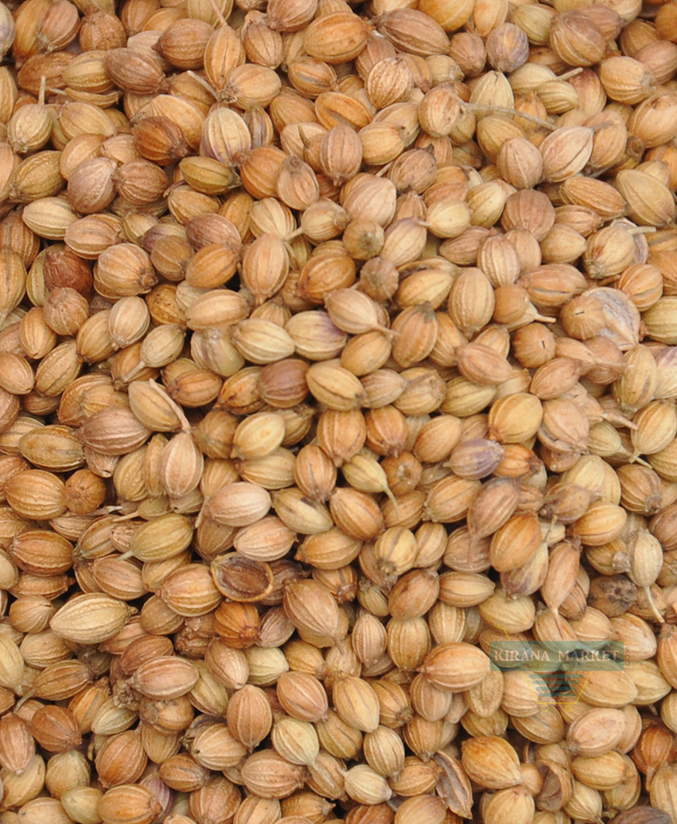

Whole coriander seeds with a mild citrusy aroma are sourced for freshness and purity. They provide a balanced flavour base for many spice blends.  
  
Used whole or ground in curries, gravies, pickles, and masalas. Dry roasting brings out a deeper, nutty aroma.

## Fennel Seeds (Saunf)

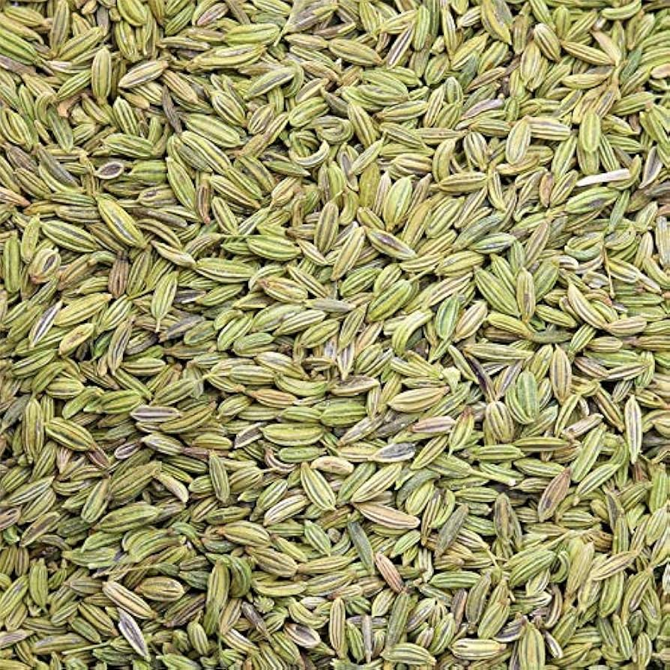

Naturally sweet and aromatic fennel seeds selected for bright colour and freshness.  
  
Used in cooking, spice blends, mouth fresheners, and digestive preparations. Adds mild sweetness and fragrance to dishes.

## Fenugreek Seeds (Methi)

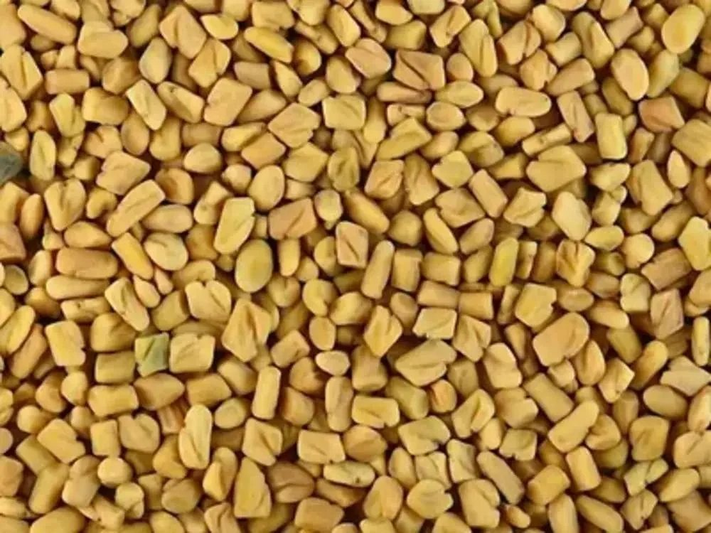

Fenugreek seeds have a distinctive bitter-sweet flavour and are widely used in Indian kitchens.  
  
Commonly added to spice blends, pickles, curries, and vegetable preparations. Light roasting reduces bitterness and enhances aroma.

## Mustard Seeds

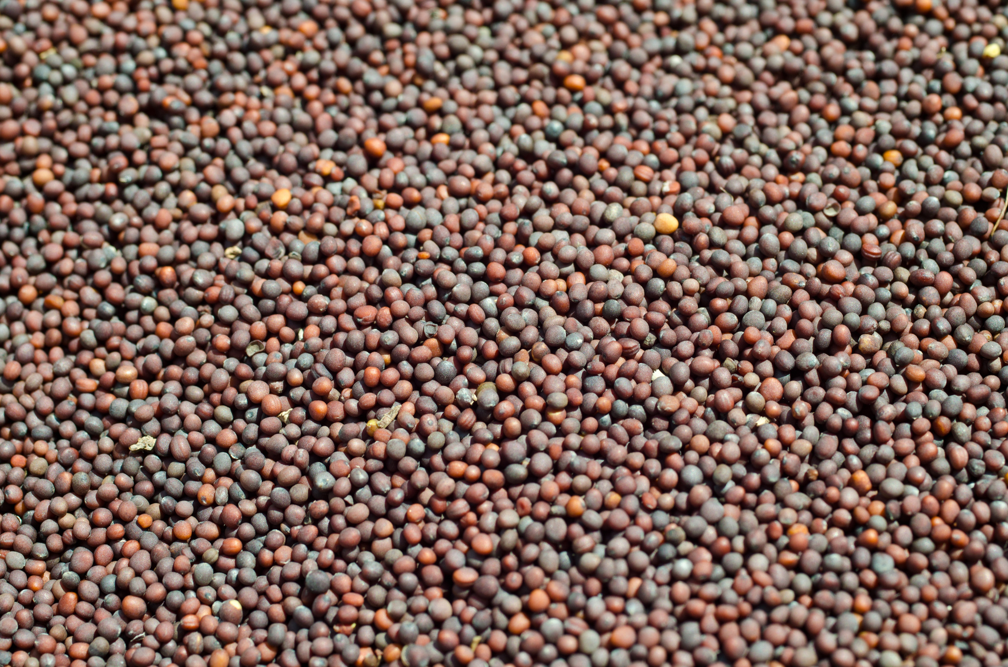

Mustard seeds are pungent and sharp, sourced for consistent size and freshness.  
  
Used mainly for tempering, pickling, and regional Indian cooking to add depth and heat.

## Turmeric (Whole)

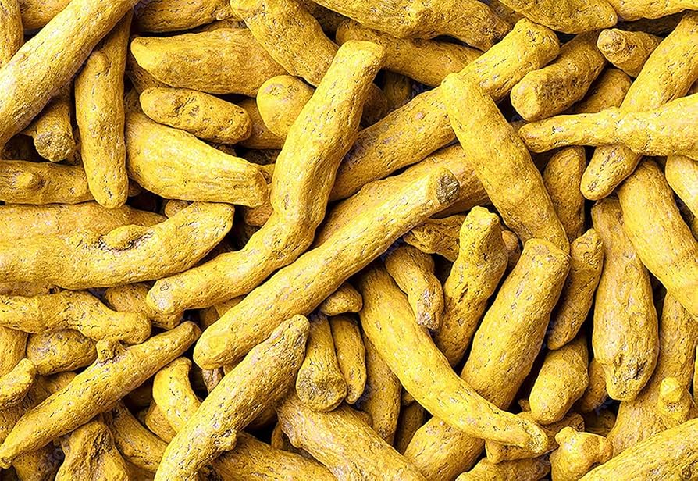

Whole turmeric fingers sourced from trusted regions known for colour and aroma. Carefully dried to retain natural potency.  
  
Used daily in Indian cooking for colour, balance, and flavour. Can be ground fresh or used in spice blends.

## Dry Ginger (Sukku)

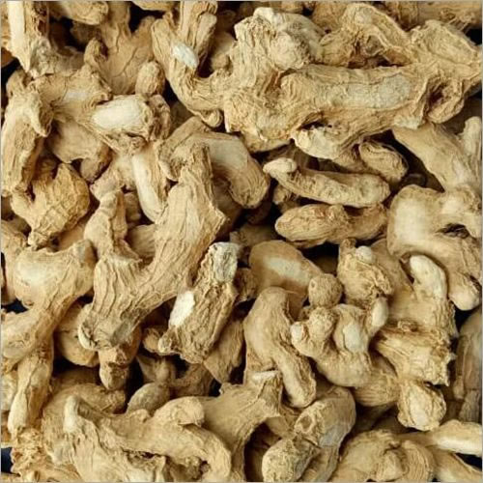

Naturally dried ginger with a strong aroma and warm, spicy profile.  
  
Used in spice blends, herbal beverages, savoury dishes, and traditional recipes to add heat and depth.

## Gundu Mundu Chilli

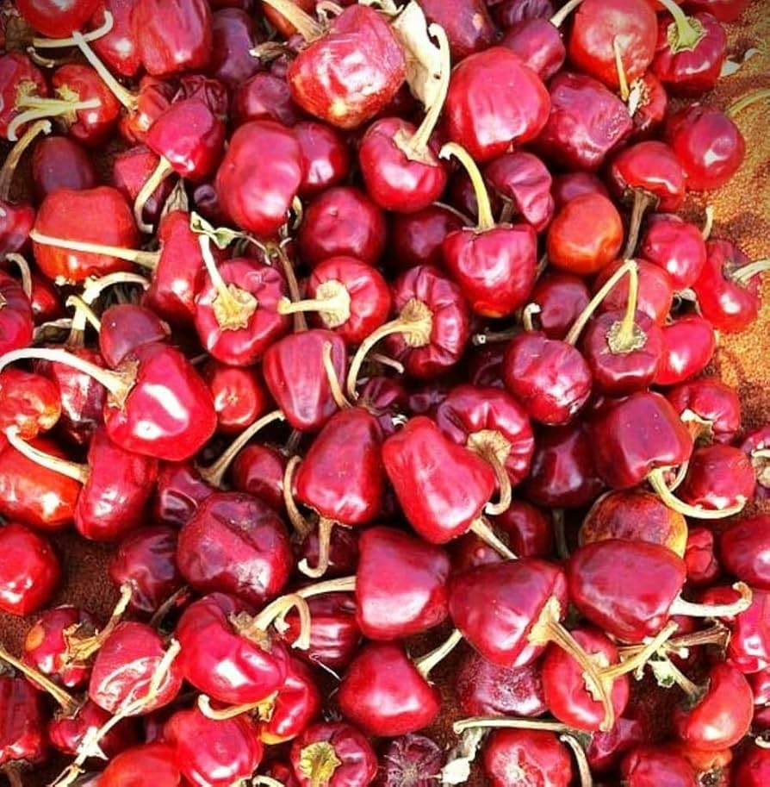

Gundu Mundu chillies are traditionally grown in South India and prized for deep red colour and moderate heat.  
  
Ideal for gravies, chutneys, and masalas where colour and flavour are preferred over sharp pungency.

## Byadagi Chilli

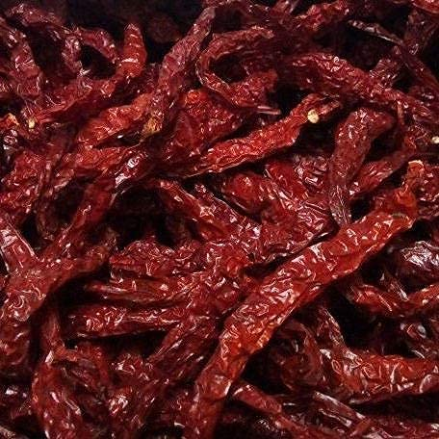

Byadagi chillies originate from Karnataka and are known for vibrant red colour with mild heat.  
  
Perfect for colour-rich gravies, masalas, and curry bases without overpowering spice.

## Cloves (Laung)

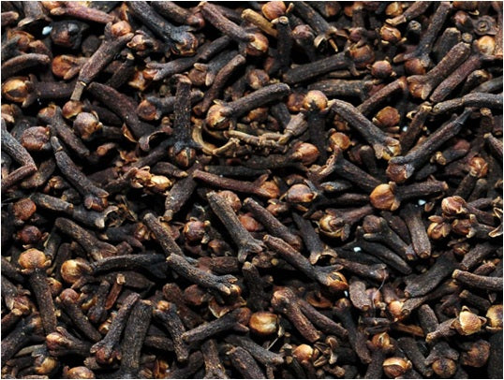

Cloves are aromatic flower buds with warm, spicy notes and natural sweetness.  
  
Used in biryanis, garam masala, desserts, and festive cooking for depth and fragrance.

## Cinnamon (Dalchini)

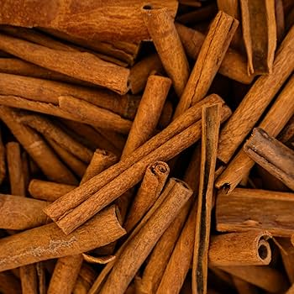

Naturally fragrant cinnamon bark with warm, sweet undertones.  
  
Used in curries, desserts, beverages, and spice blends to add richness and aroma.

## Cinnamon Roll (Cassia)

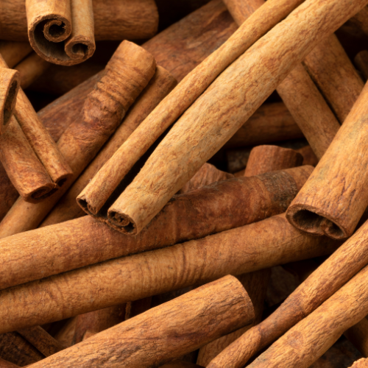

Cassia cinnamon rolls are thicker and more intense in flavour than regular cinnamon.  
  
Commonly used in Indian masalas, spice blends, and slow-cooked dishes.

## Nutmeg (Whole)

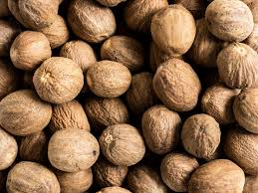

Whole nutmeg seeds with rich aroma and slightly sweet warmth.  
  
Best freshly grated for desserts, sauces, baked goods, and savoury dishes.

## Star Anise (Chakra Phool)

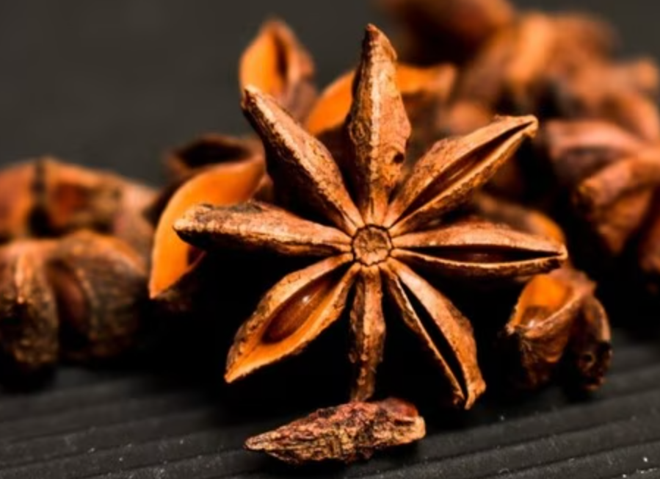

Star anise has a distinct star shape and sweet licorice-like aroma.  
  
Used in biryanis, spice blends, and slow-cooked dishes for subtle sweetness and depth.

## Tejpatta (Indian Bay Leaf)

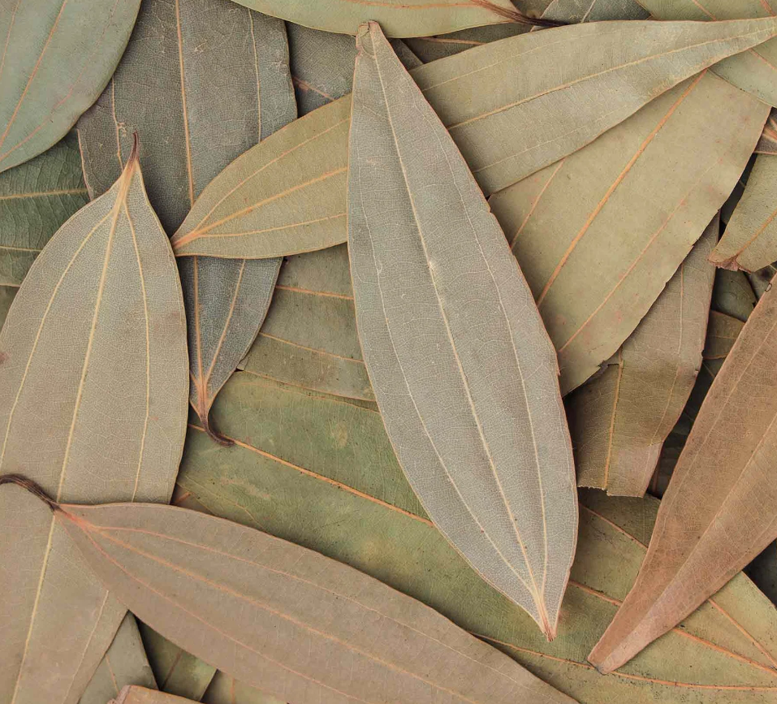

Indian bay leaves with a warm, clove-like aroma.  
  
Used whole to infuse flavour into rice dishes, curries, and stews.

## White Pepper

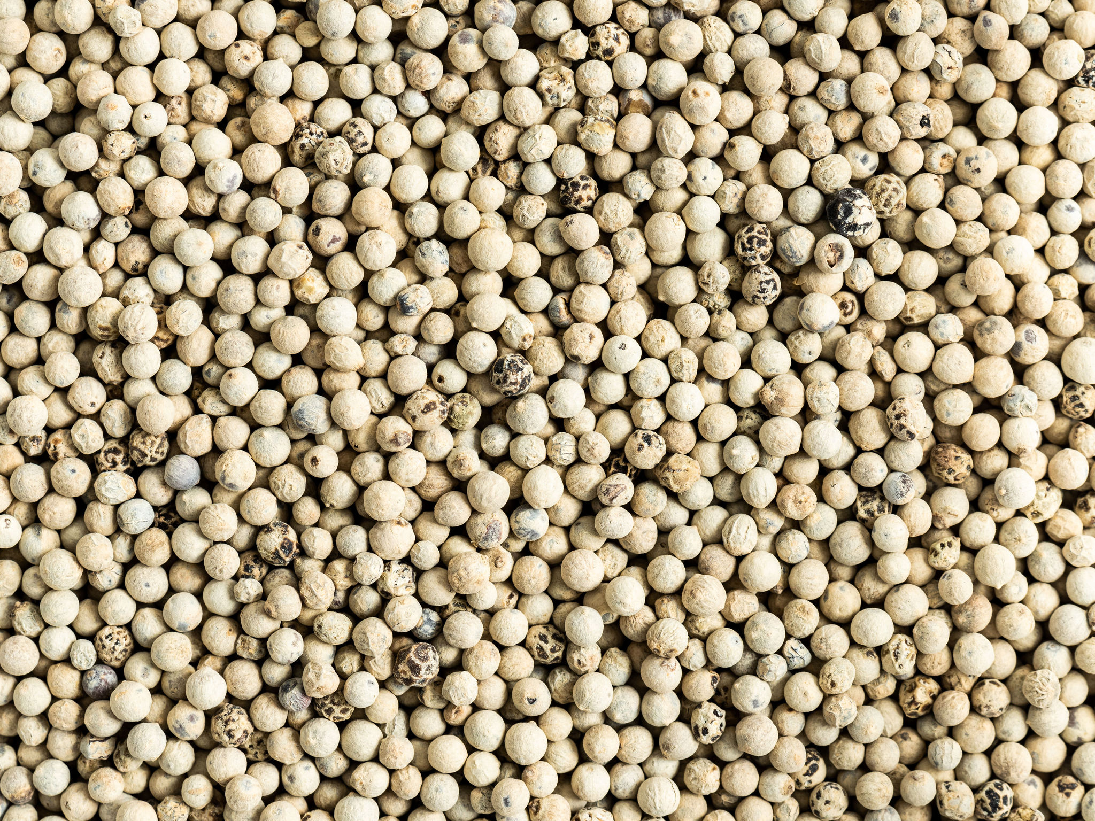

White peppercorns offer clean heat with a milder aroma compared to black pepper.  
  
Ideal for soups, sauces, continental dishes, and light-coloured preparations.

## Tamarind

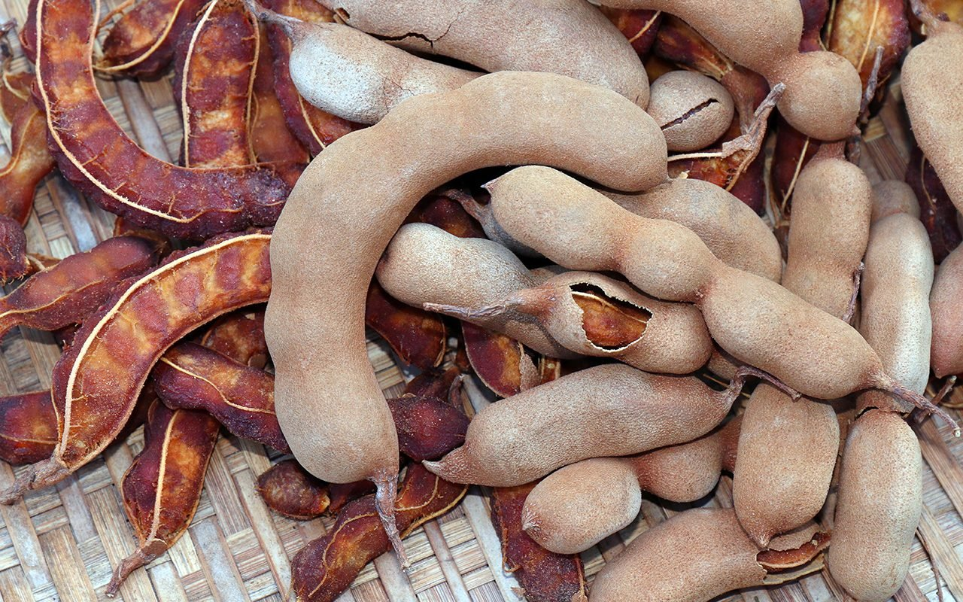

Naturally sour tamarind with rich tanginess.  
  
Used in curries, chutneys, rasam, and beverages for balanced acidity.